## Choice of businesses

We found our dataset to form natural industries where each area code exhibited multiple businesses in the same area. We then used these



### PTA 0181

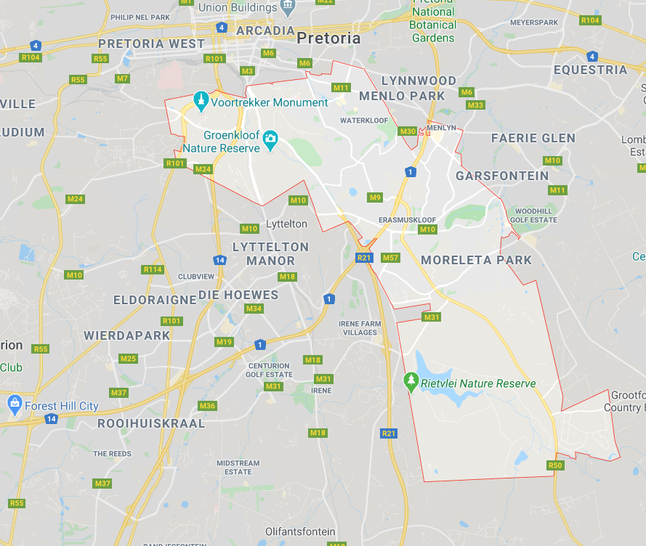

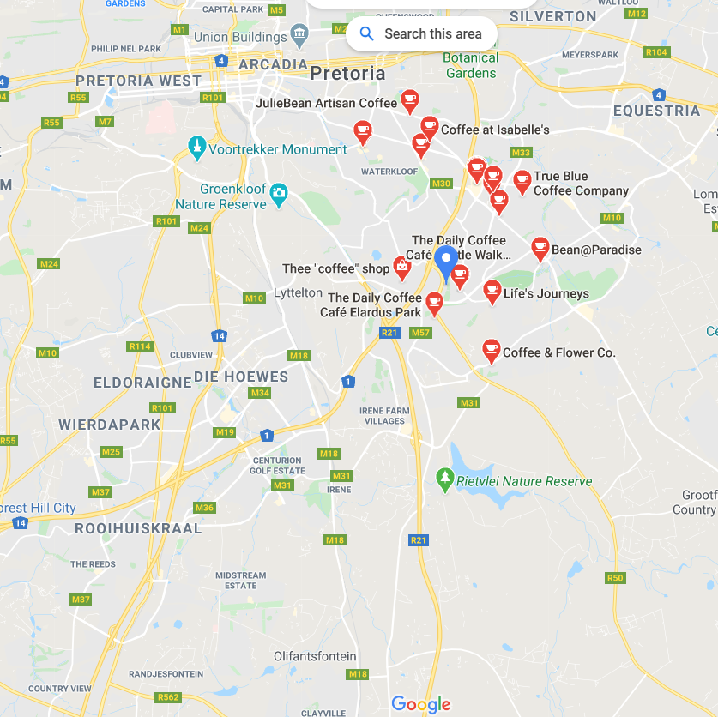

|  |  |  |  |  |
| --- | --- | --- | --- | --- |
| Coffee shops | Business | Address | Lat | Long |
| Coffee shop 1 | The Daily Coffee Café Elardus Park | 859 Barnard St, Elardus Park, Pretoria, 0181 | -25.827440 | 28.259820 |
| Coffee shop 2 | Coffee & Flower Co. | Hesketh Dr, Moreleta Park, Pretoria, 0181 | -25.8283072 | 28.2622926 |
| Coffee shop 3 | Baristas@Work Coffee Kiosk | Cnr Atterbury Street and Lois Avenue Menlyn Shopping Centre, Menlyn, Pretoria, 0181 | -25.7831182 | 28.2747349 |

### Potch 2520

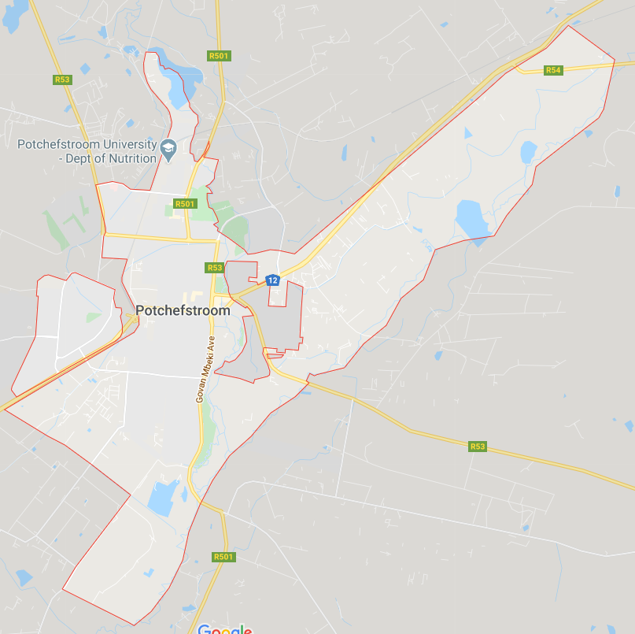

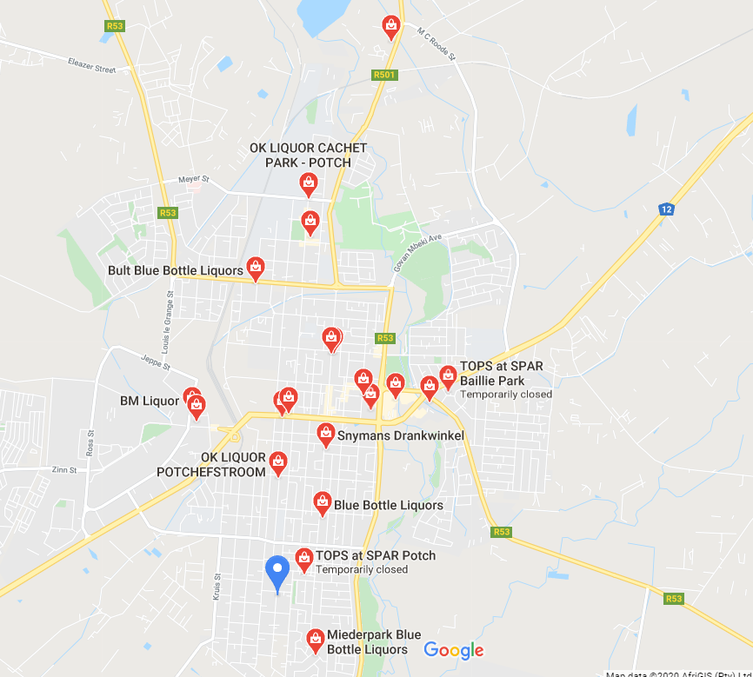

|  |  |  |  |  |
| --- | --- | --- | --- | --- |
| Liquor Store | Business | Address | Lat | Long |
| Liquor Store 1 | BM Liquor | 14 Durr St, Potchindustria, Potchefstroom, 2520 | -26.7139956 | 27.0826799 |
| Liquor Store 2 | Overland Liquors | Potchefstroom, 2520 | -26.7161641 | 27.104509 |
| Liquor Store 3 | Booze Oppie Bult Drankwinkel | 98 Steve Biko St, Potchefstroom, 2520 | -26.7040357 | 27.0825088 |

### Queens 5319

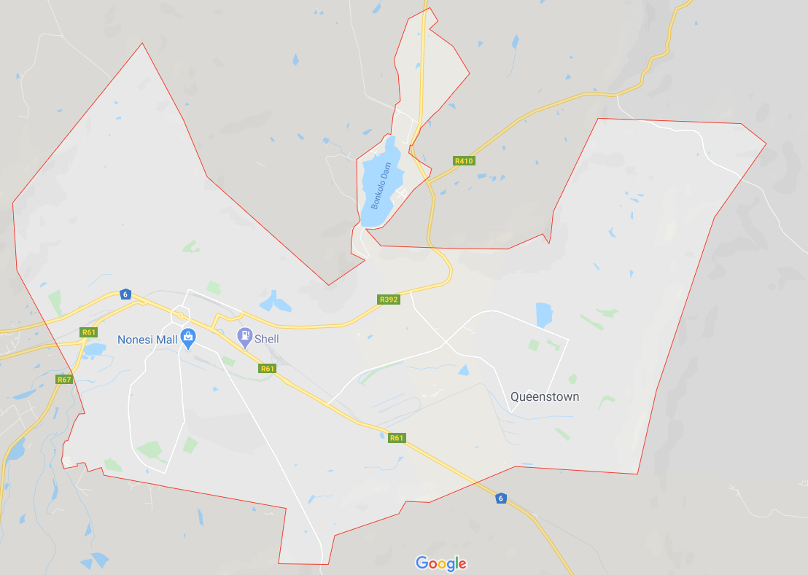

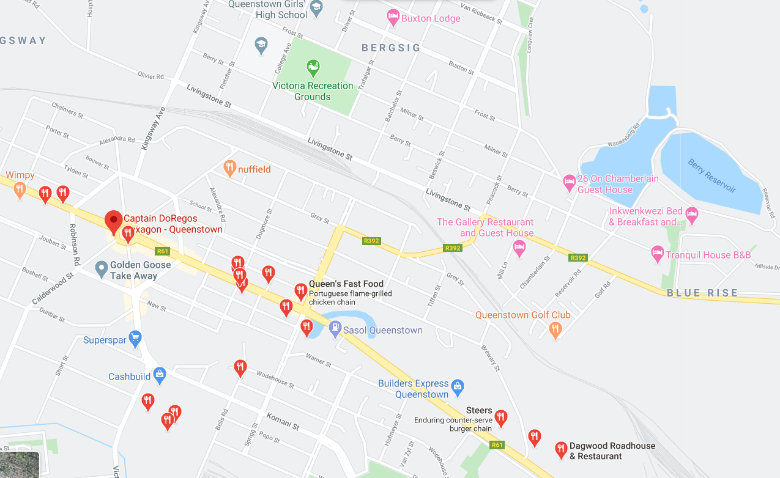

|  |  |  |  |  |
| --- | --- | --- | --- | --- |
| Fast Food | Business | Address | Lat | Long |
| Fast Food 1 | Queen's Fast Food | 1 Cathcart Rd, Queenstown, 5319 | -31.9005439 | 26.8778015 |
| Fast Food 2 | Captain DoRegos Hexagon - Queenstown | 9 The Hexagon, Queenstown, 5319 | -31.8960166 | 26.8696667 |

### Stellenbosch 7600

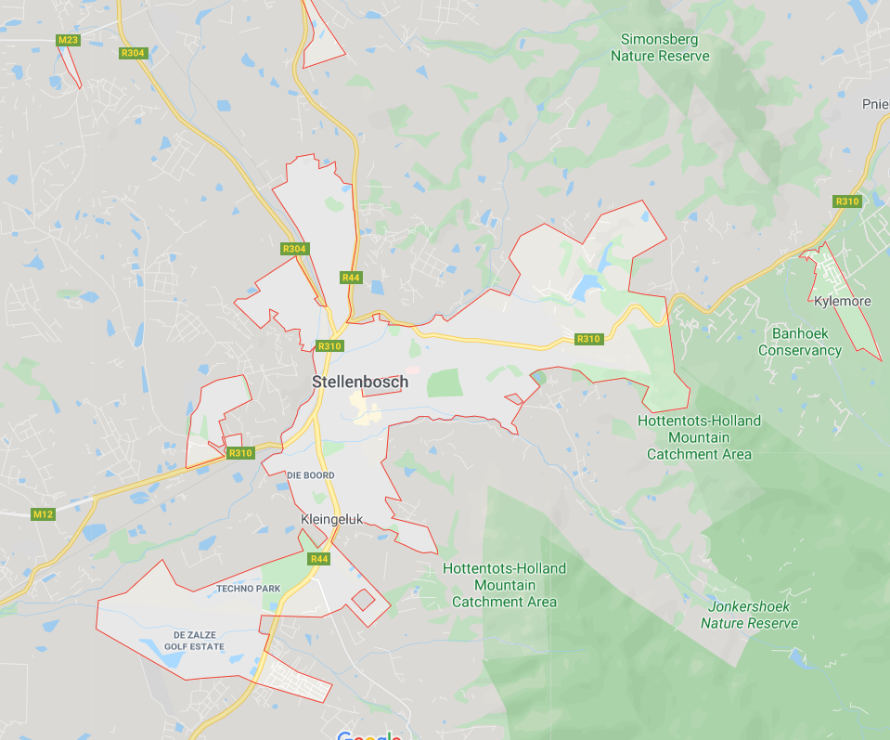

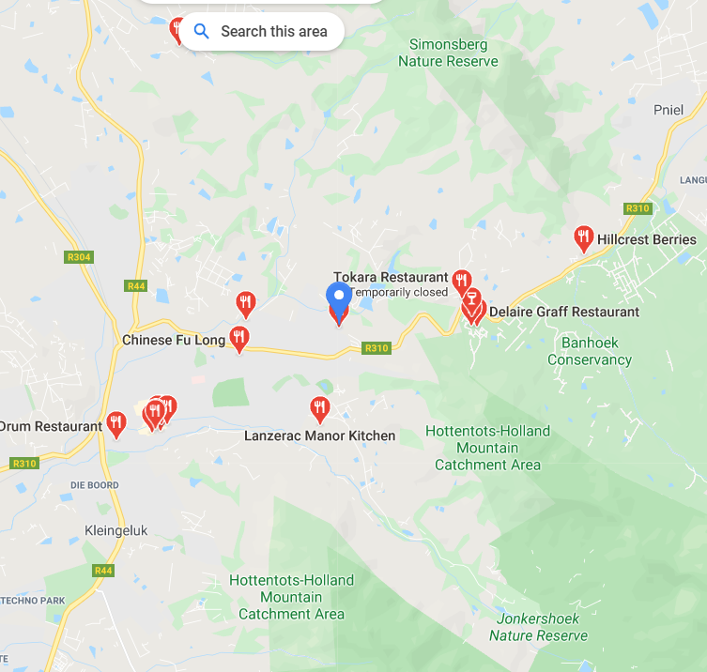

|  |  |  |  |  |
| --- | --- | --- | --- | --- |
| Restaurants | Business | Address | Lat | Long |
| Restaurant 1 | Drum Restaurant | Drum Restaurant, Second Floor of Black Horse Centre Corner of Dorp Street and, Mark St, Stellenbosch, 7600 | -33.9390145 | 18.8559878 |
| Restaurant 2 | Chinese Fu Long | 28 Cluver Rd, Simonswyk, Stellenbosch, 7600 | -33.9286762 | 18.8746257 |
| Restaurant 3 | De Stomme Jonge | 3 Ryneveld St, Stellenbosch Central, Stellenbosch, 7600 | -33.9382896 | 18.8614553 |
| Restaurant 4 | NcaKos | 7 De Beer Rd, Stellenbosch, Cape Town, 7600 | -33.9325389 | 18.8653646 |

### Athlone 7764

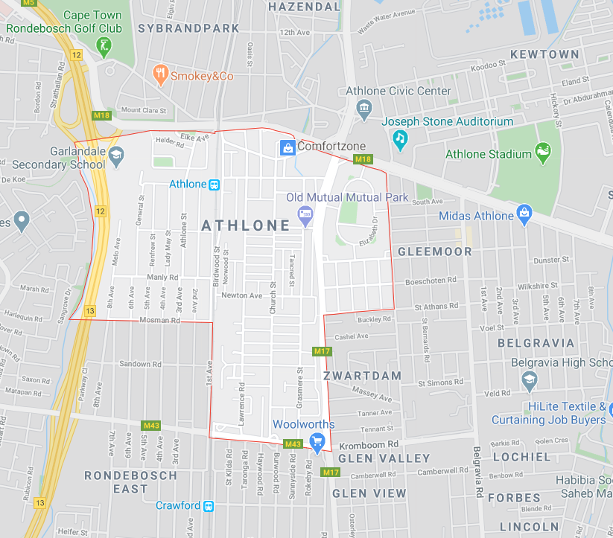

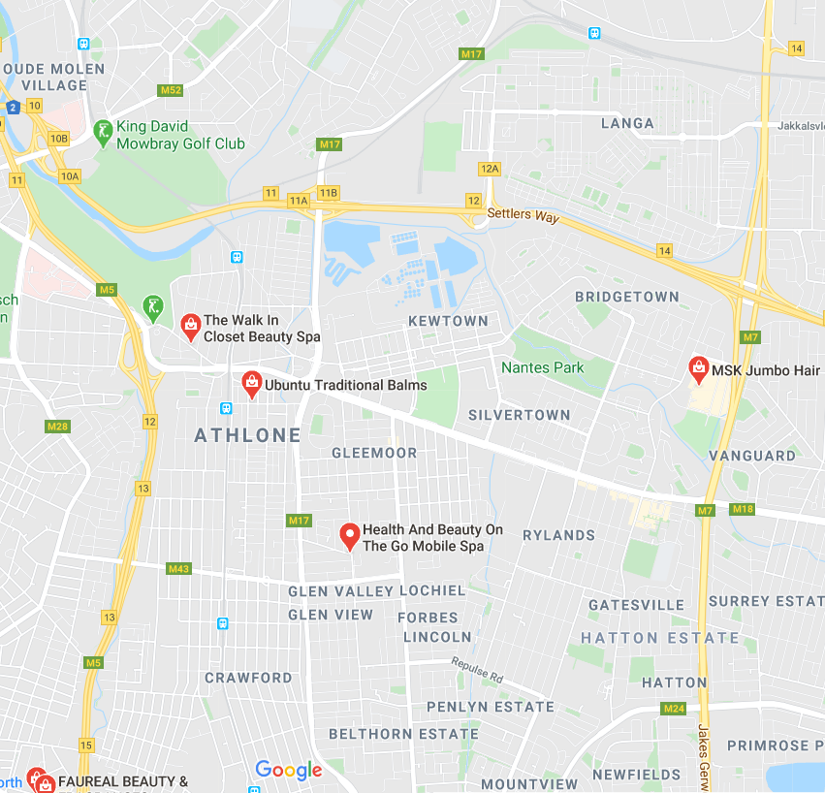

|  |  |  |  |  |
| --- | --- | --- | --- | --- |
| Beauty store | Business | Address | Lat | Long |
| Beauty 1 | The Walk In Closet Beauty Spa | 19 Golf Course Rd, Sybrandpark, Cape Town, 7700 | -33.966293 | 18.5038933 |
| Beauty 2 | NEW IMAGE HAIR & BEAUTY SALON | Corner of, Aden Avenus, Church St, Athlone, Cape Town, 7764 | -33.9657271 | 18.5041949 |
| Beauty 3 | Marlene's Hair Salon | Athlone, Cape Town, 7764 | -33.9628503 | 18.5060414 |

* Note: How do we define Beauty store. We included Hair and Nails and other cosmetics stores.

### Kuruman 8460

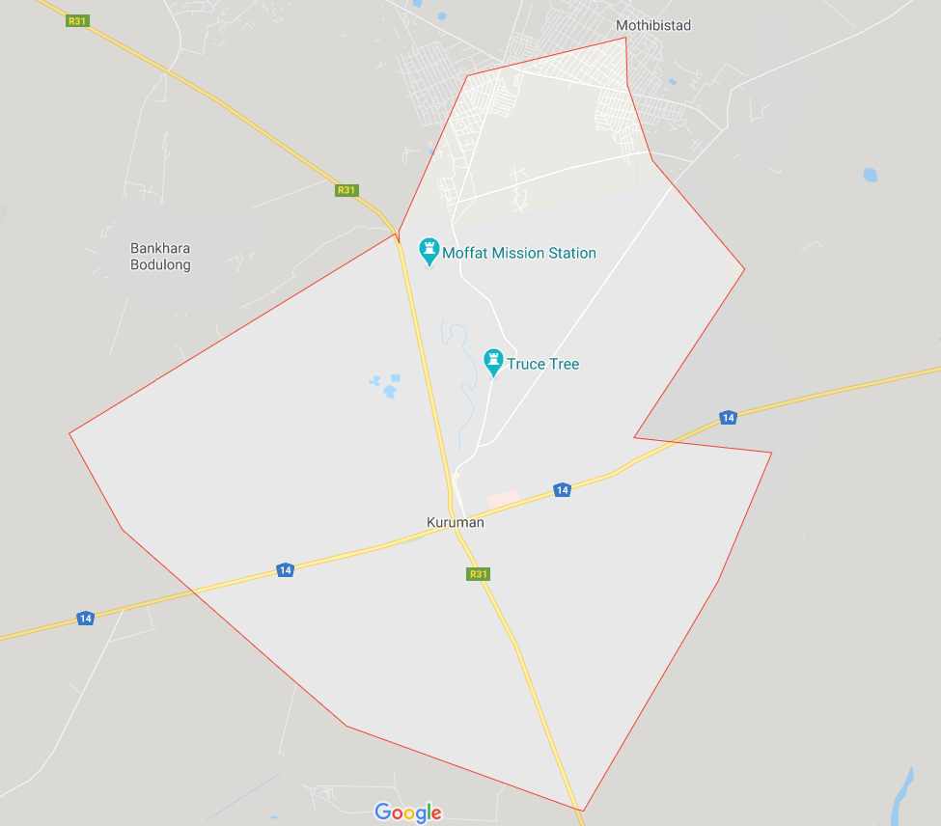

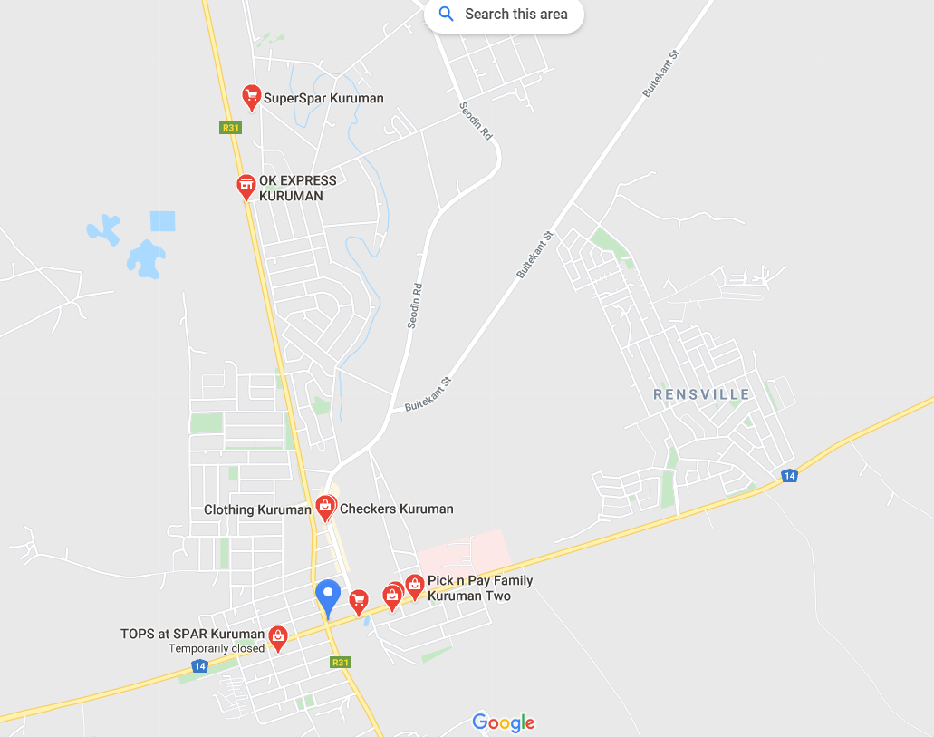

|  |  |  |  |  |
| --- | --- | --- | --- | --- |
| Minimarkets | Business | Address | Lat | Long |
| Minimarket 1 | Ruben Crazzy Corner | 3648 Spreeu St, Kuruman, 8460 | -27.4588856 | 23.4335296 |
| Minimarket 2 | Price N Pride | 18 Livingstone St, Kuruman, 8460 | -27.4575644 | 23.4340224 |
| Minimarket 3 | Die Meelwinkel | Tsenin Rd, Kuruman, 8460 | -27.4572385 | 23.4330026 |